**Convolution Neural Networks:**

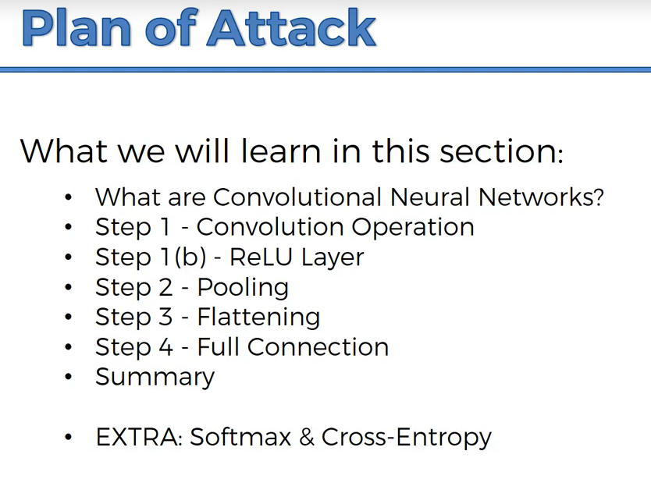

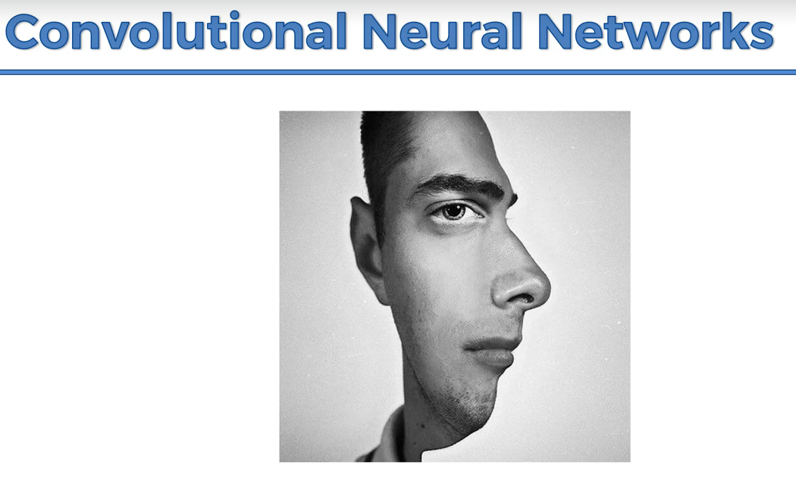

Brain will pick the features based on which the brain classifies the image.

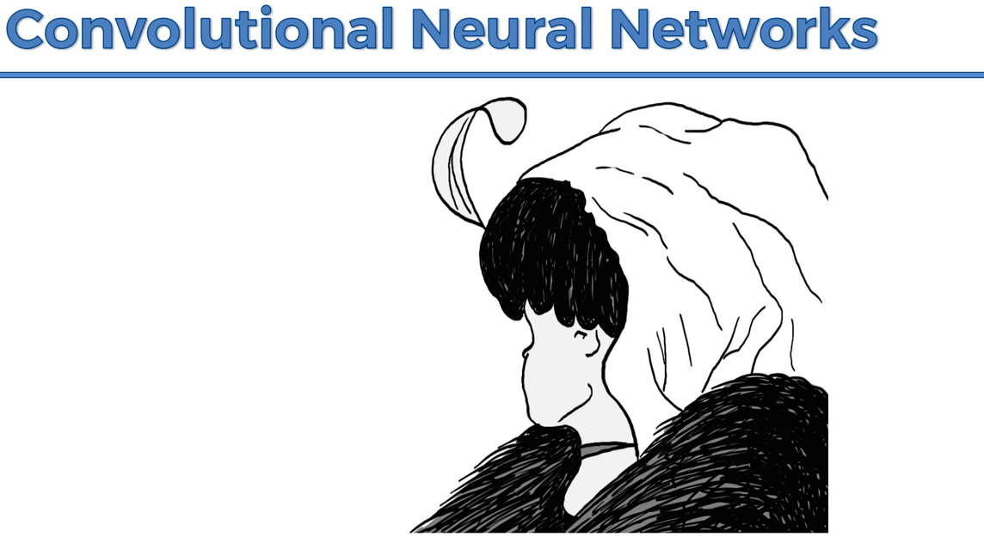

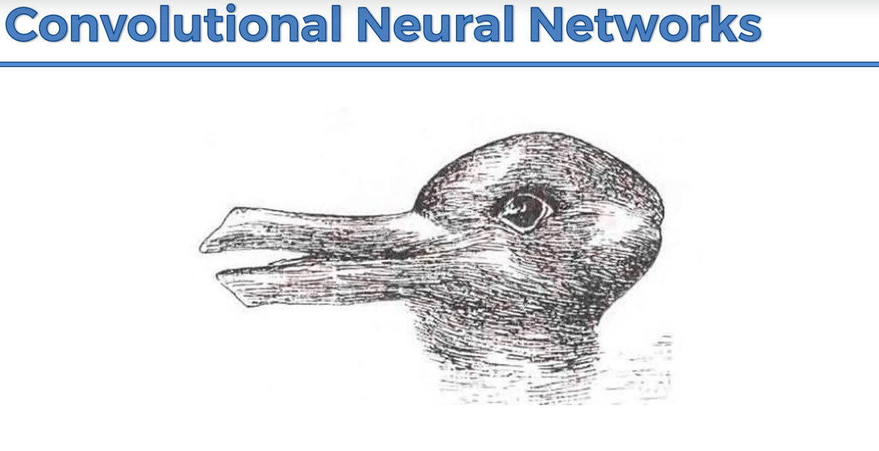

Brain is trying to understand the image by switching the eye in the image.

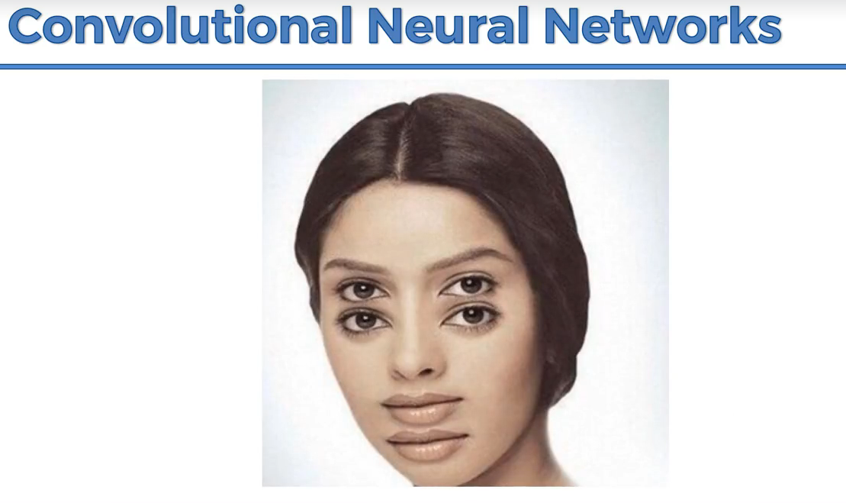

CNN will process the images and predict the image.

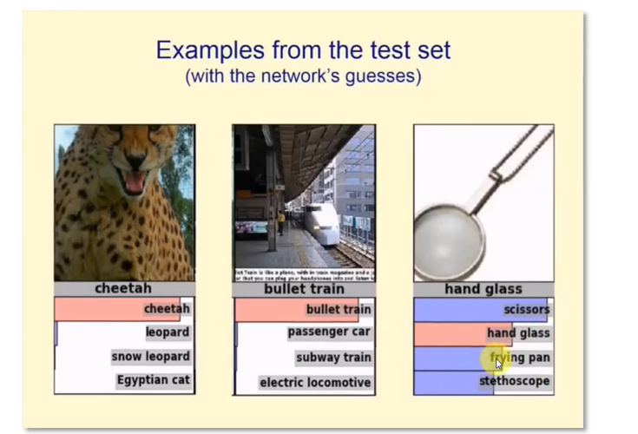

**Working of CNN:**

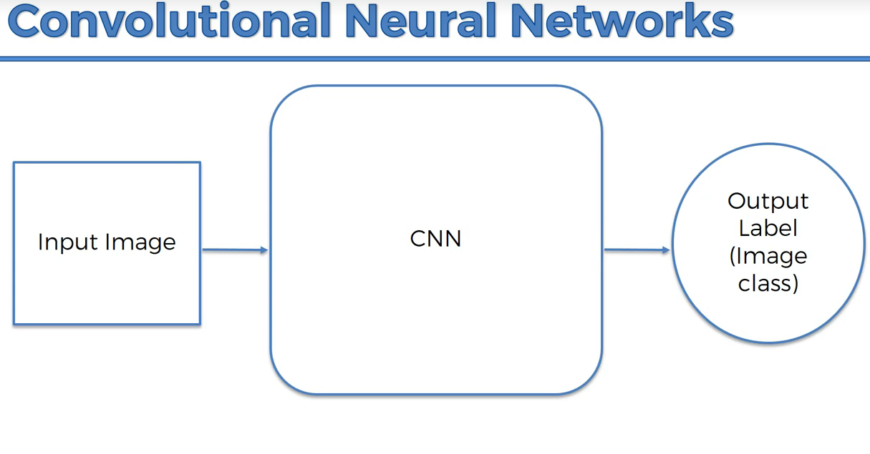

CNN can recognize emotions,

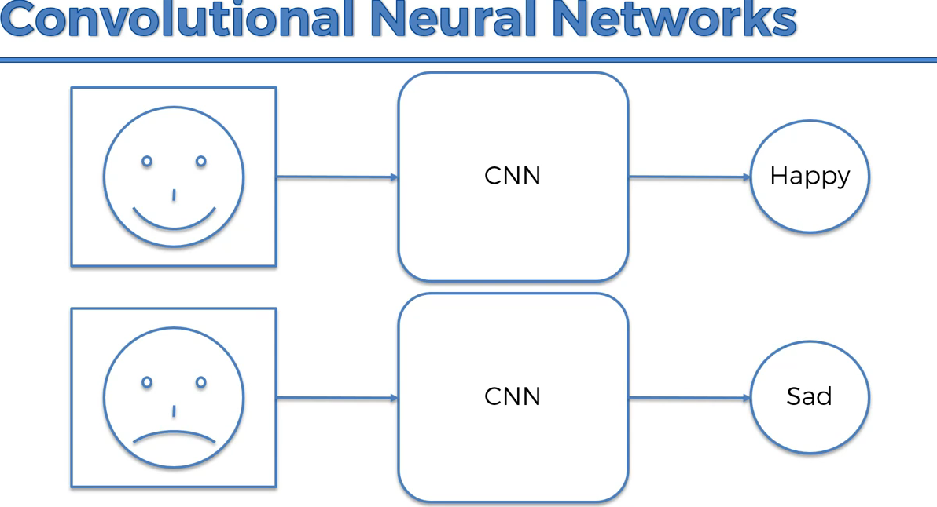

Sometimes if the image is not clear, CNN accuracy can reduce like human brain

**Drill down of CNN working:**